MAC LAYER IN WIRELESS SENSOR NETWORK

ABHILASH REDDY TATHIREDDY

SIDDHARATH GURRAMKONDA

MANIRATNAM PALKUR

**Abstract: -**

In the current scenario of the world where Internet of Things(IOT) are scaling up and becoming more prominent, And Wireless sensor networks are the key elements for these IOT. And WSN should be designed in such a way that it should less power and should be able to receive the data without any miss of its data packets that is receiving. In this paper, we have discussed about the wireless sensor and MAC layer importance. And we also discussed about the different types of MAC layers present. And we also discussed the importance of the Time-based MAC protocol of WSN and how it is different to other protocols and in the implementation and comparisons results of energy saved by using the TMAC protocol.

**INTRODUCTION: -**

**What is a wireless sensor network?**

A wireless sensor network (WSN) is a remote system comprising of spatially conveyed independent devices that utilize sensors to cooperatively screen physical or natural conditions, for example, noise, vibration, temperature, mass, movement, or poisons at various locations [8].

**Understanding wireless sensor networks:**

Before continuing with the Wireless Sensor Network, we must realize the need and conditions which prepared to the creation of Wireless Sensor Network. Regularly the systems we use in our work places comprise of PCs, Laptops, Mainframes, Smartphone's and Tablets and so on. These frameworks are based on the idea of "Human – System" Interaction. In this sort of system human interfaces with the system for data handling. This entire setup is in an indirect way associated with Physical condition [12]. Physical condition is read by user and user collaborates with system. Then again there are setups where systems communicate with Physical condition and modifies itself. Both the situations are portrayed in figure 1 and 2.

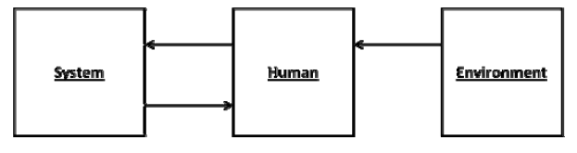

Fig 1. System Human Interaction

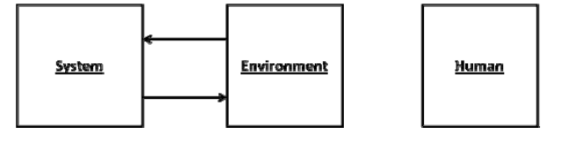

Fig 2. System Environment Interaction

As we can see from Fig 2 that system itself is proficient for communication with condition and this prompts to what is called as "Embedded System". Examples are washing machines, microwave oven, synthetic process plant or a temperature controlling unit in a Blast furnace. As the technology is propelling our capacity to give this sense to huge machines has likewise created a passion to give it to small devices and things identified in our everyday life and this innovation is known as "The Ambient Intelligence". Ambient implies surrounding which deduces giving intelligence to the surrounding. Precisely what is implied by this can be understood after an example. Visualize if our surrounding understands us. When we reach our home and entrance opens naturally when it detects us. Lights are on when we go into the room and music is played as per the individual's interest. This is an absolute combination of "User – System – Physical Environment"[12].

Now going above and beyond, imagine a scenario in which these sensors which are detecting us also speaks with each other and frame a system. This sort of system has numerous applications. Their application may extend from military administrations, therapeutic to disaster relief operations. So for making this imagination in to reality we have to create devices which are little and yet have the accompanying abilities:

* Processing power for locally available processing.
* Transmitter and Receiver.
* Power Supply.
* Sensors to cooperate with Physical condition [12].

**Goal of WSN and their fields of prominence:**

The goal of a WSN is to gather and process information from an objective area and transmit data back to specific sites. WSN innovation is a developing technology that can be used in an extensive variety of potential applications including yet not restricted to, biomedical treatment, military applications, movement reconnaissance, fire recognition, auxiliary and tremor observing, industrial control, save operations, shrewd spaces, restorative frameworks and robotic exploration [2].

**Structure of WSN and their functionality:**

Now, getting to the detail of the Wireless Sensor Network, we have small devices called nodes which are spread in a region in a specific pattern or in an arbitrary design. They are equipped for connecting with each other and transmitting the information to each other. Generally, this sort of system has a "sink" or base station where all the data accumulated is transmitted. This sink, is thus, associated with the remote PC or a device observing the entire framework as appeared in Fig.3. This remote PC can be a server or a mainframe.

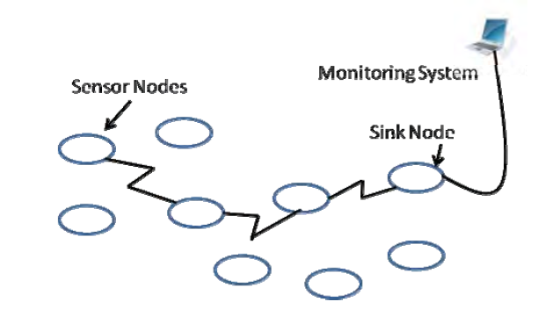

Fig.3 Wireless Sensor Network

For various functions of the applications wireless sensor networks use a group of autonomous sensors [11]. WSNs have been growing fast since last few years. There are numerous nodes in WSNs which can collect sensorial data and deliver them to remote repositories [3]. These nodes or sensors are small electronic devices which are less in weight and economic in pricing. The sensors however are battery-controlled that are regularly sent in unattended hostile sites, which makes the power source of the sensors vital and non-restorative. Besides, the sensors contribute with each other to empower transmission and reception between multi-jump nodes [6]. The most eminent issues in regards to WSNs are the trouble in transmitting data in a remote condition, and also the energy costs inferred. The signal blurs, obstructions, channel inhabitance and obstruction with different gadgets propel the utilization of effective systems to send and get packets effectively.

Additionally, there are other specific issues in WSNs identified with the memory and handling. These systems have restricted resources in view of the cost and size of the devices. The sensors are tiny with a specific end goal to be versatile to a wide range of situations and ready to be introduced in different conditions, areas and foundations. This additionally makes the batteries be minute and momentary; therefore, this is the need to spare energy in all procedures of the system [8].

**MAC (media access control) layer:**

In wireless sensor networks media access control (MAC) layer is an imperative layer. Medium access control (MAC) is an essential method that guarantees the effective operation of the system. One of the primary function of the MAC protocol is to maintain a strategic distance between the interfering nodes. Designing power proficient MAC protocol is one of the approaches to extend the life time of the system [11].

Wireless sensor networks have several nodes to transmit the data, Sensor nodes communicate by framing a multi-hop system to forward messages to the destination, which may gather information for later recovery by the end user or exchange the information over a dedicated communication link. Sensor nodes stay away from direct correspondence with a distant destination due to the high transmission power requirements for dependably sending messages over the deployment region, which may cover an extensive geographical region [16]. Despite utilizing multi-hop communication to reduce energy requirements for transmission, the remote transceiver frequently consumes the biggest measure of energy—per time period of utilization—inside a sensor node and, in this way, gives the best potential for energy reserves. Beyond enhancing the radio plan, an effective medium access control (MAC) protocol has the best capability to reduce the energy utilization of the transceiver since it directly controls the transceiver operation [16].

A MAC convention gives slightly different functionality upon the network, device capacity, and upper layer requirements, however several functions exist in most MAC protocols. In general, a MAC convention gives:

• Framing – Define the frame format and perform data exemplification and de-capsulation for correspondence between devices.

• Medium Access – Control in which devices take part in communication anytime. Medium access turns into a fundamental capacity of wireless MAC protocols

since broadcasts easily create corrupt data through collisions.

• Reliability – Ensure successful communication between devices. Generally

finished through acknowledgement (ACK) messages and re-transmissions

whenever necessary.

• Flow Control – Prevent frame loss through overloaded buffers of the recipient.

• Error Control – Use error correction or error detection codes to control the

measure of errors present in frames conveyed to upper layers [16].

Wireless sensor networks have distinct needs than the regular networks and is self-organizing, so due to the limited resources wireless sensor networks requires some distinct MAC protocols [1]. Different varieties of applications have different purposes and a group of autonomous sensors are used by the wireless sensor networks to fulfil the task. These networks are reliable and efficient because of their abilities such as self-organization and failure adaptation [11]. The reliability and efficiency should be calculated by considering many factors such as consistency of the protocol or necessity of application environment.

**Current Scenarios in MAC: -**

At present, there a significant number Medium Access Control(MAC) protocols that are prepared for the Wireless Sensor Networks(WSN) (10). Any proposed MAC protocols need to be energy efficient by reducing energy wastes. In this paper, we are mainly concentrating on Timeout MAC(T-MAC) protocol, other than this protocol we have like,

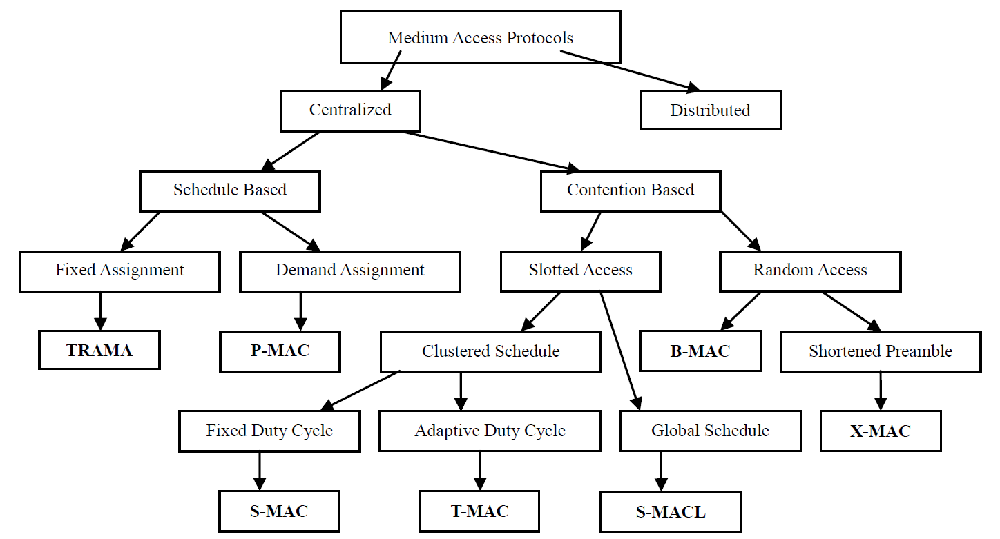

Fig 4: MAC layer options. (10)

1.**Sensor MAC (S-MAC): -**

S-MAC is mainly designed to extend the network lifetime by using the listen or sleep frame to reduce the energy consumption also, this controls their duty cycles to above 10%, reducing energy waste by trying to reduce idle listening. (10)



Fig 5: - S-MAC periodic listen/sleep (14).

In S-MAC during sleep time, nodes shut down transceivers to save energy while in wake-up time, sensor nodes become connected with each other and transmit a several number of control messages such as synchronization(SYNC), acknowledgement (ACK), request to send(RTS), clear to send(CTS). (14)

2.**Pattern MAC(P-MAC): -**

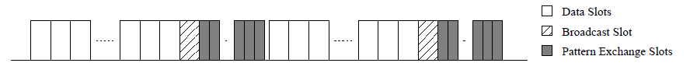

Fig 6: - PMAC frame format (16).

PMAC is an alternative technique for scheduling time slots which includes the PMAC protocol as well. The above figure shows that the frame format for PMAC protocol, many data slots begin the frame and allows the sensor nodes to transfer the data messages. (16)

3. **Traffic-Adaptive MAC (TRAMA): -**

TRAMA protocol attempts to stabilize the uses of scheduled and unscheduled protocols by making availability of scheduled slots with no disagree for a longer data messages and different access slots for small, periodic control messages. (16)

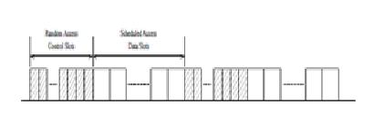

Fig 7: - TRAMA frame format [16]

This protocol consists of 3 components, namely:

1. Schedule exchange protocol(SEP).
2. Adaptive Election Algorithm(AEA).
3. Schedule Exchange Protocol(SEP).

TRAMA make use of single, time-slotted channel which are made an entry that is divided up into random, scheduled access periods. (10)

4.**B-MAC, a versatile low power MAC: -**

B-MAC uses a carrier sense medium access(CSMA) protocol. The node wakes up at every check interval, in which the radio samples the channel and verifies that if any activity is took place during the preamble period. This will stay just for receiving data, if there is no data available the time out makes the node to sleep. (13)

The key challenge of this protocol is applying the check intervals that are short which then guarantee a reasonable length for the preamble. The duration of the carrier sense should also have to be short so that the receiver doesn’t spend a lot of energy in listening to the communication channels. (10)

5.**X-MAC, a short preamble MAC: -**

This protocol solves the P-MAC issues which ae embedding the target ID in the preamble so that the other node can go back to the sleep.

This embedding short pauses occurs between the preamble packets, so if the Rx wakes up and it can send an acknowledgment during this pause and cut the preamble to start sending data. (13)

6.**Timeout MAC: - (TMAC)**

This MAC protocol is similar to S-MAC in which this utilizes a wake/sleep duty cycle. In other words, T-MAC improves upon the design of S-MAC by implementing an adaptive duty cycle in which the wake part is dynamically ended, by increasing the efficiency of the algorithm for variable traffic loads. (10)

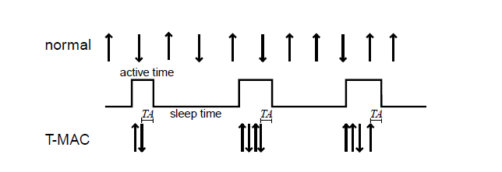

Fig 8: T-MAC protocol scheme (18).

From figure, it shows that the simple scheme of T-Mac protocol. Each node simultaneously comes to active mode to communicate with their neighbors, and fall back to sleep mode until the next frame. And a node will always keep listening and potentially transmitting until it is in active mode. The active mode ends when no activation event has done for a time TA. Generally, activation event is:

1. Discharge of a periodic frame timer.
2. Response of any type of data on the radio.
3. Sensing of communication on the radio.
4. End-of transmission of a node’s own data packet. (18)

The main idea behind the design of T-MAC is, while latency requirements and the spaces between the buffers are generally fixed and the message rate will vary. In order, to solve this efficiency the T-MAC protocol reduces idle listening by transmitting all messages in bursts of lengths and sleep in between the bursts. (10)

In TMAC, sensor node drift away to sleep period if none act occurred for a time ‘Tact’(TA) as shown in fig. The time interval TA is greater than sum of the disputed time, length of the RTS packet. This complete scenario results in the energy consumption in which less in TMAC when compared with SMAC protocol. (12)

T-MAC considers the buffer size of the sensor node when calculating the contention period. The sensor nodes which have a full buffer can take a priority and may control the channel by quickly sending a request to send a message after receiving a request from another sensor anode. (16)

The advantage in TMAC is, it can easily handle variable load because of dynamic sleeping schedule. Disadvantage of TMAC is, it has an early sleeping problem in which nodes might sleep as per their activation time and even the data might get lost especially for long messages. (12)

**Determining TA: -**

A node should not go to sleep if its neighbors are still communicating, since it may be the receiver of a subsequent message. Receiving the start of the RTS or CTS packet from a neighbor is enough to trigger a renewed interval TA. Because the node is not in range it may not hear which RTS might start the communication with its neighbors, the interval TA must be long enough to receive at least the start of the CTS packet (Fig. 3). This observation gives us a lower limit on the length of the interval TA: TA > C + R + T where C is the length of the contention interval, R is the length of an RTS packet, and T is the turn-around time (i.e. the short time between the beginning of the CTS packet and start of the RTS packet). In T-MAC experiments, TA = 1.5 × (C + R + T), which proved to be satisfactory. A larger TA increases the energy used.

**T-MAC Problem: -**

In Fig. 9. Each of the nodes A Though D in the picture forms a cell with its neighbors. Messages flow from top to bottom, so node A sends only to B, B only to C, and C only to D. Now consider node C. Every time it wants to send a message to D, it must contend for the medium and may lose to either node B (by receiving an RTS packet) or to node A (indirectly, by overhearing a CTS packet from node B). If node C loses contention because of an RTS packet from node B, it will reply with a CTS packet, which can also be heard by node D. And when the communication between C and B ends, node D will be awake. However, if node C loses contention because it overhears a CTS packet from B to A (see Fig. 9), C must remain silent. Since D does not know of the communication between A and B, its active time will end, and node D will go to sleep. Only at the start of the next frame will node C have a new chance to send to node D. Therefore, the chances of sending every packet from node C to node D may either succeed or fail. (by losing to node A). Both events have equal probability. Failure implies that the frame ends and C can send no more packets. Therefore, in the simplified setup, node C has the probability of 50% of sending single packet to node D. And a 25% probability of sending two packets (it must succeed twice), etcetera, in each frame. We call the observed effect the early sleeping problem, since a node goes to sleep when a neighbor still has messages for it. The node-to-sink communication pattern causes, early sleeping problem reduces the total possible throughput of T-MAC to less than half of the maximum throughput of traditional protocols or S-MAC. In later experiments, it is also encountered this problem at the border of a highly active part of the networks. It is believed that, the problem might occur in any asymmetric communication pattern. [19]

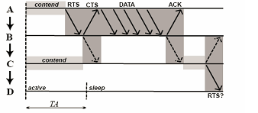

Fig 9: The early sleeping problem Node D goes to sleep before C can send RTS to it.

**Experiments: -**

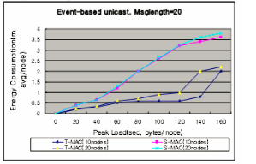

Fig 10: Peak Load vs Energy consumption (with 10,20 nodes)

The purpose of the experiments is to measure the energy consumption of two protocols: S-MAC, T-MAC. To evaluate the performance of two protocols, we use OMNET++ simulator performing the tests on a simple topology of 10 nodes and 20 nodes. We change the number of nodes to measure energy consumption in different traffic load.

In the Fig. 10 events occur in the network with a frequency of one per 10 seconds. Events have an average duration of 5 seconds and affect an area of approximately 10 nodes. A neighbor that receives one of these messages replies with a probability of 20%. We performed multiple measurements, with different message frequencies during events. This frequency is

on the horizontal axis of the graph (Fig. 11). T-MAC is using overhearing avoidance but no full-buffer priority. T-MAC uses much less energy than the S-MAC, especially when the message frequency during events increases. However, the maximum frequency that T-MAC can handle is lower than that of S-MAC, thus it may occur that the energy consumption increases if the traffic load and the number of nodes is increasing. Again, T-MAC suffers from the early sleeping problem [19].



Fig 11: Power usage trace idle

**Power usage: -**

After the implementation of the T-MAC protocol, we performed several power usage experiments. In these experiments, one node was sending, another receiving. We measured the power consumption of both the sending and the receiving node. The message length is 20 bytes. The voltage over the resistor is a measure for the electrical current. This voltage was measured using Surge View, which is a Java application that comes standard in the Tiny OS Tools distribution. The Surge View is useful for monitoring a sensor network and analyzing mesh network performance. At the computer, we captured the values. After precise calibration, we could measure the electrical current through the node with a precision of approximately 15µA. Fig 10. shows a power usage trace of an idle node. The power consumption is low most of the time. At regular intervals (0.61 seconds, the frame time) we see spikes to 4mA. These are the active times, during which the radio is on. We also see two higher spikes. These are SYNC packet transmissions. Fig 12. shows a close of a node transmitting 3 messages during a single frame. We expected that there is no control packet like RTS/CTS/ACK causing reasonable power consumptions [19].



Fig 11: Power usage trace, transmitting node, 10 messages/second.

**Conclusion: -**

The reduction of the power consumption is one of the major issues in WSNs, and the efficient management of the radio transceiver is the key element to achieve this objective [4]. Here, in this paper we simply explained the different types of the MAC layers that can be applicable to WSN. And along with those we also focused mainly on the T-MAC protocol comparison with the other MAC layer protocols and explained the advantages and the statistical differences among all other MAC protocols. The performance of T-MAC under low peak load having a low traffic is better than the S-MAC in same condition in small networks [19].

**References: -**

1.Yi, Wei, and John Heidemann. "An Energy-Efficient MAC Protocol for Wireless Sensor Networks." IEEE INFOCOM (2002): n. pag. Web.

2.Ahmad Abed Alhameed Alkhatib. "MAC Layer Overview for Wireless Sensor Networks."

2012 International Conference on Computer Networks and Communication Systems 35 (2012): n. pag. Web.

3.Caldeira, João M. L. P., Joel J. P. C. Rodrigues, and Pascal Lorenz. "MAC layer handover mechanism for continuous communication

support in healthcare mobile wireless sensor networks." Telecommunication Systems 60.1 (2014): 119-32. Web.

4. Mainetti, Luca, Vincenzo Mighali, and Luigi Patrono. "HEC-MAC: A Hybrid Energy-Aware Cross-Layer MAC Protocol for Wireless Sensor Networks." International Journal of Distributed Sensor Networks 11.4 (2015): 536794. Web.

5.Yessad, Samira, Louiza Bouallouche-Medjkoune, and Djamil Aïssani. "A Cross-Layer Routing Protocol for Balancing Energy Consumption

in Wireless Sensor Networks." Wireless Personal Communications 81.3 (2014): 1303-320. Web.

6.Singh, Buddha, and D. K. Lobiyal. "A MAC-Layer Retransmission Technique for Collided Packets in Wireless Sensor Network."

Wireless Personal Communications 72.4 (2013): 2499-518. Web.

7.Bhar, Jamila. "A Mac Protocol Implementation for Wireless Sensor Network." Journal of Computer Networks and Communications 2015 (2015): 1-12. Web.

8.Del-Valle-Soto, Carolina, Carlos Mex-Perera, Aldo Orozco-Lugo, Mauricio Lara, Giselle Galván-Tejada, and Oscar Olmedo.

"On the MAC/Network/Energy Performance Evaluation of Wireless Sensor Networks: Contrasting MPH, AODV, DSR and ZTR Routing Protocols.

" Sensors 14.12 (2014): 22811-2847. Web.

9.Jolly, Gaurav, and Mohamed Younis. "An energy-efficient, scalable and collision-free MAC layer protocol for wireless sensor networks.

" Wireless Communications and Mobile Computing 5.3 (2005): 285-304. Web.

10.Gunn, Meghan, and Simon G. M. Koo. "A Comparative Study of Medium Access Control Protocols for Wireless Sensor Networks.

" International Journal of Communications, Network and System Sciences 02.08 (2009): 695-703. Web.

11.Sumita, Nagah. "Hyrbrid MAC protocols for wireless sensor network.

" International Journal of Emerging Technologies in Computational and Applied Sciences (IJETCAS) (n.d.): n. pag. Web.

12.KHATARKAR, Sarika. "Wireless Sensor Network MAC Protocol: SMAC & TMAC.

" Indian Journal of Computer Science and Engineering (IJCSE) 4th ser. 4 (2013): n. pag. Web.

13.Alhameed Alkhatib, Ahmad Abed. "MAC Layer Overview for Wireless Sensor Networks.

" 2012 International Conference on Computer Networks and Communication Systems 12 (2012): n. pag. Web.

14.Ramadan, Khalil F., M. I. Dessouky, Mohammed Abd-Elnaby, and Fathi E. Abd El-Samie.

"Energy-efficient dual-layer MAC protocol with adaptive layer duration for WSNs."

2016 11th International Conference on Computer Engineering & Systems (ICCES) (2016): n. pag. Web.

15.Sha, Mo, Rahav Dor, Gregory Hackmann, Chenyang Lu, Tae-Suk Kim, and Taerim Park.

"Self-Adapting MAC Layer for Wireless Sensor Networks." 2013 IEEE 34th Real-Time Systems Symposium (2013): n. pag. Web.

16.Kredo, Kurtis, and Prasant Mohapatra. "Medium access control in wireless sensor networks." Computer Networks 51.4 (2007): 961-94. Web.

17.Singh, Brajendra Kumar, and Kemal Ertugrul Tepe. "A novel real-time MAC layer protocol for wireless sensor network applications."

2009 IEEE International Conference on Electro/Information Technology (2009): n. pag. Web.

18. Dam, Tijs Van, and Van Langendoen. "An Adaptive Energy-Efficient MAC Protocol for Wireless Sensor Networks." (2003): n. pag. Web.

19. LEE, WOOCHL, YUTAE LEE, SOONGHEE LEE, and DONGIL KIM. "Analysis of S-MAC/T-MAC Protocols for Wireless Sensor Networks." Analysis of S-MAC/T-MAC Protocols for Wireless Sensor Networks (July 10-12, 2006): n. pag. Web.